**Due in class on Wednesday, November 6, 2019.**

Type your answers within the word document provided by the instructor. Please note that the work handed in must be your own.

Programming Output

For each of the given program segments, read the code and write the output in the space provided below.

For questions 1 – 3 assume the following class definition:

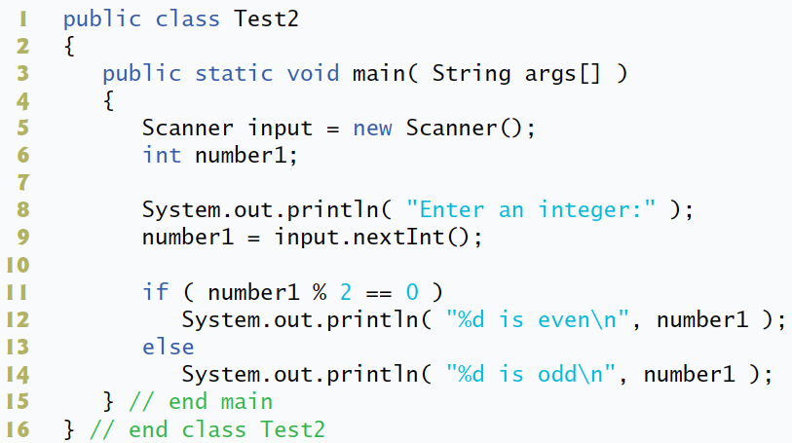

1. What will be the output by lines 11-14 if the user enters the integer 2 at line 9?

***2 is even***

1. What will be the output by lines 11-14 if the user enters the integer 3 at line 9?

***2 is odd***

1. What will be the output if the following code is placed at line 10 of the preceding class definition? Assume that the user enters 5.

*number1 = number1 + 3;*

***8 is even***

1. What will be the output by the following program?

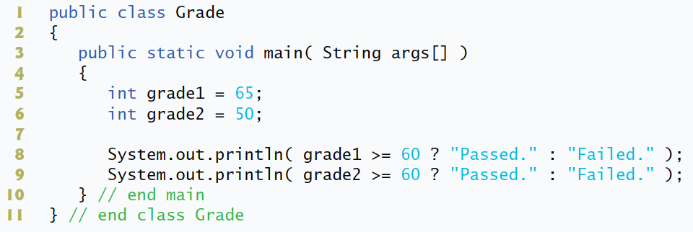

***Passed.***

***Failed.***

For questions 5 – 7 assume the following class definition:

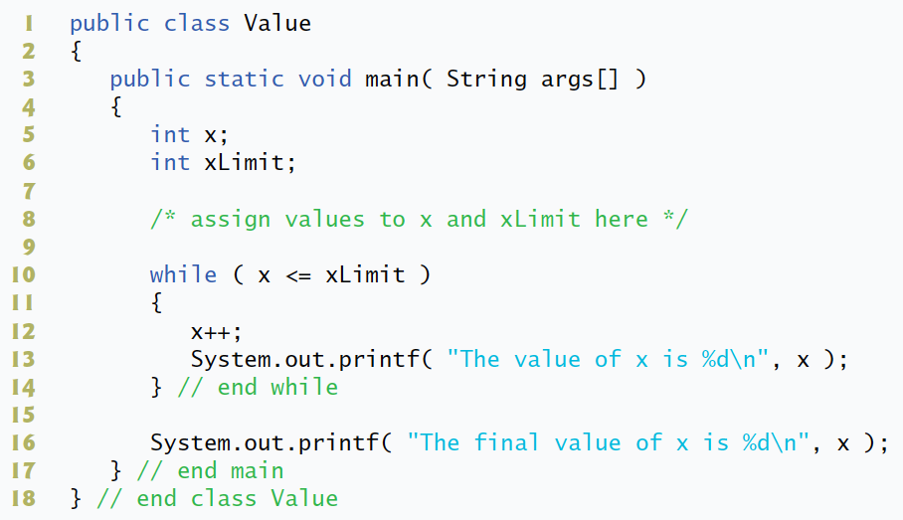

1. What will be the output if the following code is placed at line 8 of the class?

*x = 1;*

*xLimit = 5;*

***The value of x is 2***

***The value of x is 3***

***The value of x is 4***

***The value of x is 5***

***The value of x is 6***

***The final value of x is 6***

1. What will be the output if the following code is placed at line 8 of the class?

*x = 1;*

*xLimit = -2;*

***The final value of x is 1***

1. What will be the output if the following code is placed at line 8 of the class?

*x = 10;*

*xLimit = 5;*

***The final value of x is 10***

For questions 8 – 10 assume the following class definition:

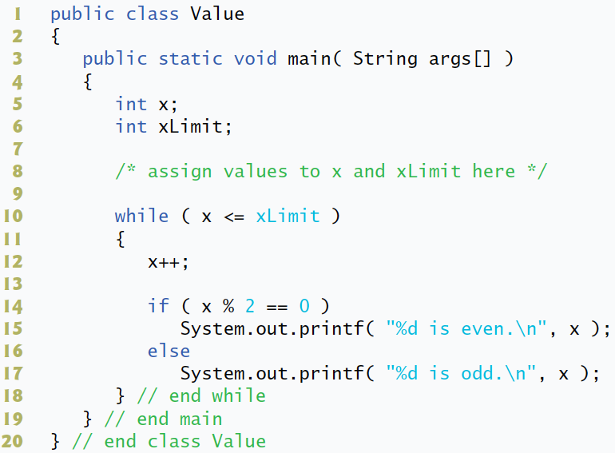

1. What will be the output if the following code is placed at line 8 of the class?

*x = 0;*

*xLimit = 10;*

***1 is odd.***

***2 is even.***

***3 is odd.***

***4 is even.***

***5 is odd.***

***6 is even.***

***7 is odd.***

***8 is even.***

***9 is odd.***

***10 is even.***

***11 is odd.***

1. What will be the output if the following code is placed at line 8 of the class?

*x = 0;*

*xLimit = -2;*

**Nothing will be printed.**

1. What will be the output if the following code is placed at line 8 of the class?

*x = 10;*

*xLimit = 5;*

**Nothing will be printed.**

Correct the Code

Determine if there is an error in each of the following program segments. If there is an error, specify whether it is a logic error or a compilation error, circle the error in the program and write the correct code in the space provided after each problem. If the code does not contain an error, write “no error”. [Note. There may be more than one error in each program segment.]

1. The following segment of code should calculate whether a student has passing grade. If so, the code should print “Passed.” Otherwise, the code should print “Failed.” and “You must take this course again.”

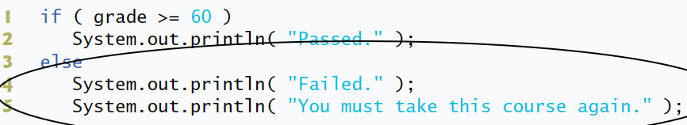

**A logic error, the correction:**

***else***

***{***

***System.out.println( “Failed” );***

***System.out.println( “You must take this course again.” );***

***}***

1. The following while loop should compute the product of all the integers between 1 and 5, inclusive.

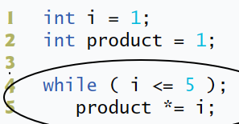

**A logic error, the correction:**

***while ( i <= 5 ){***

***product *= i;***

***i++;***

***}***

1. The following while loop should print all the even integers between 0 and 20, inclusive.

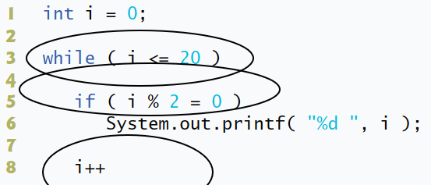

**Compilation and logic errors, the correction:**

***while ( i <= 20 )***

***{***

***if ( i % 2 == 0)***

***System.out.printf( “%d ”, i );***

***i++;***

***}***

1. The following while loop should print all the even integers between 20 and 0, inclusive.

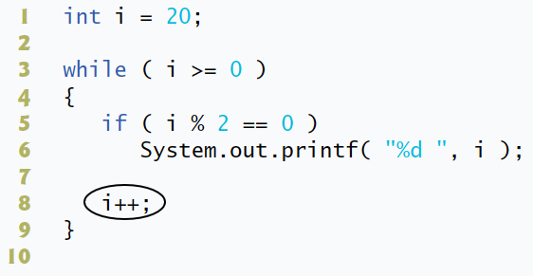

**A logic error, the correction:**

***while ( i >= 0 )***

***{***

***if ( i % 2 == 0)***

***System.out.printf( “%d ”, i );***

***i--;***

***}***

1. The following while loop should print the sum of the integers between 0 and 5, inclusive.

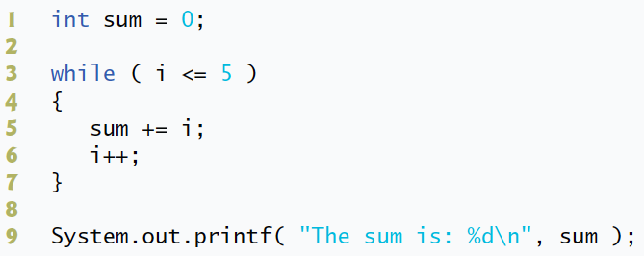

**No errors, if we assume that variable i has been initialized. If not, it is a compilation error, and might be corrected by adding *int i = 0;* to the line 2.**

1. The following while loop should print the product of the odd integers between 0 and 10, inclusive.

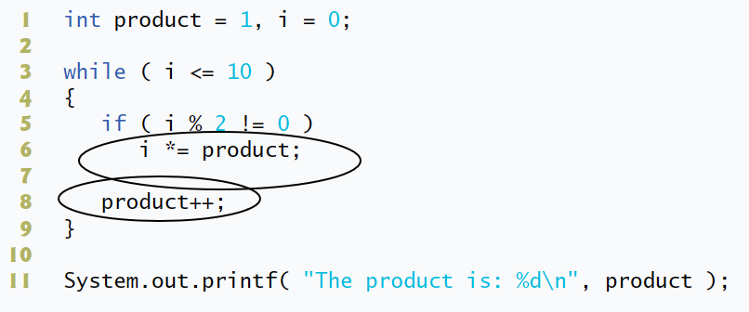

**A logic error, the correction:**

***if ( i % 2 != 0)***

***product *= i;***

***i++;***

if ( gender == 1 )

System.out.println( "Woman" );

else *~~if ( gender == 1 )~~*

System.out.println( "Man" );

**A compilation error, the correction:**

***if ( gender == 1 )***

***System.out.println( "Woman" );***

***else***

***System.out.println( "Man" );***

while ( z >= 0 )

sum += z;

**A compilation error, the correction:**

***while ( z >= 0 )***

***{***

***sum += z;***

***z--;***

***}***

String number = “1”;

switch ( number )

{

case ~~1~~:

System.out.println( "The number is 1" );

break;

case ~~2~~:

System.out.println( "The number is 2" );

break;

default:

System.out.println( "The number is not 1 or 2" );

break;

}

**A compilation error, the correction:**

***String number = “1”;***

***switch ( number )***

***{***

***case “1”:***

***System.out.println( "The number is 1" );***

***break;***

***case “2”:***

***System.out.println( "The number is 2" );***

***break;***

***default:***

***System.out.println( "The number is not 1 or 2" );***

***break;***

***}***

for ( int i =0; i <= n; i++ )

{

System.out.println( "The number is " + i );

if ( i == n )

i = i – n;

}

**A logic error, an infinite loop. I have not an exact idea how it might be corrected, because I don’t know what is waited to be executed. If I change *for ( int i =0; i <= n; i++ )* to *for ( int i =0; i < n; i++ )*, if statement will not be executed. So, I suppose that from several possible ways, the best way is**

for ( int i =0; i <= n; i++ )

{

System.out.println( "The number is " + i );

if ( i == n )

i = i + n;

}